16.AIM:-To implement UML diagrams for Online Internship Registration System..

1.COMPONENT DIAGRAM:-

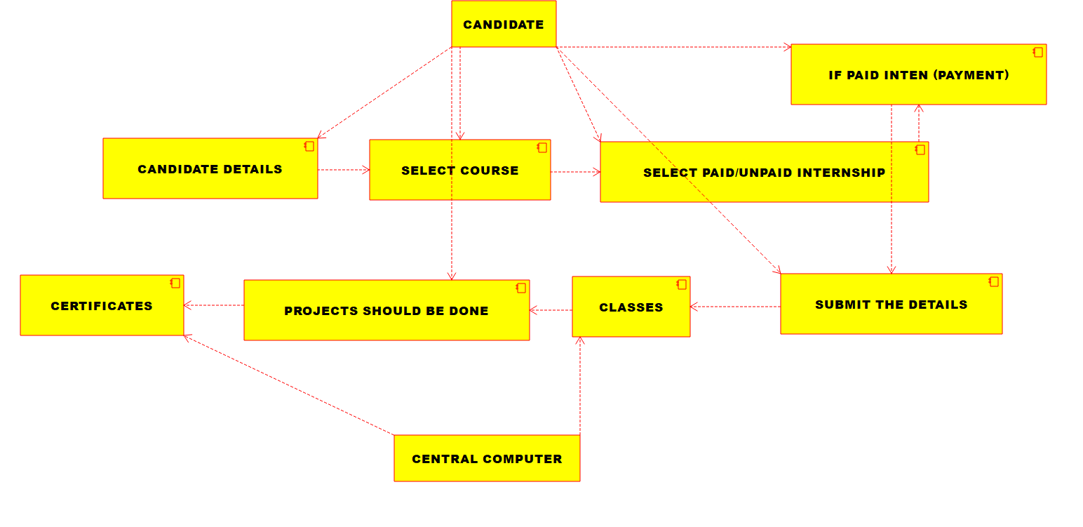

2.Deployment diagram:-

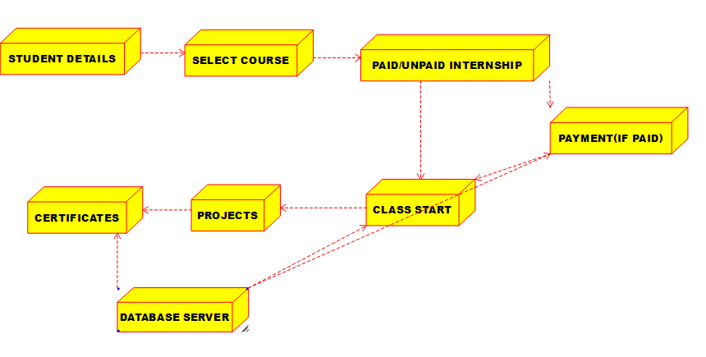

3.ACTIVITY DIAGRAM:-

